**Requirement Analysis Document**

**Subsystem:** Inertial Sensing Unit

**Last date of revision:** 16-02-2023

**Document status:** Draft

**Authors:** Thiruvarulselvan K

*Revision history:*

*1. First draft completion- 02/02/2023*

*2. Addition of system model - 10/02/2023*

*3. Addition of data parameters - 16/02/2023*

***Abbreviations:***

***CPM - Central Processing Module***

**Purpose of the subsystem:**

Measure the essential parameters of the rocket and communicate with the CPM

| **Type** | **Requirement** | **Priority** |
| --- | --- | --- |
| **(Functional, Technical, Operational)** | **(Core, Essential, Desired)** |
| Functional | Measure the rocket kinetic parameter such as **Velocity, Acceleration, Attitude (roll, pitch, and yaw), Altitude.** | Core |
| Functional | Measure the **Airspeed on the airframe, Vibration on the airframe, Motor temperature, Atmospheric temperature and humidity, and System Voltage and Current** | Core |
| Functional | Acquire the real-time location of the rocket | Core |
| Operational | Measures the parameters in the appropriate range associated with the rocket’s range of capabilities | Essential |
| Operational | Should provide required signal resolution and sampling rate | Essential |
| Technical | Should be powered with the CPM’s output power supply | Essential |
| Technical | Sampling rate of each sensor should be relative to each other to maintain data sync | Desired |
| Technical | The sensing units should withstand the effect of changes in the physical parameters during the entire mission | Desired |

Subsystem model:

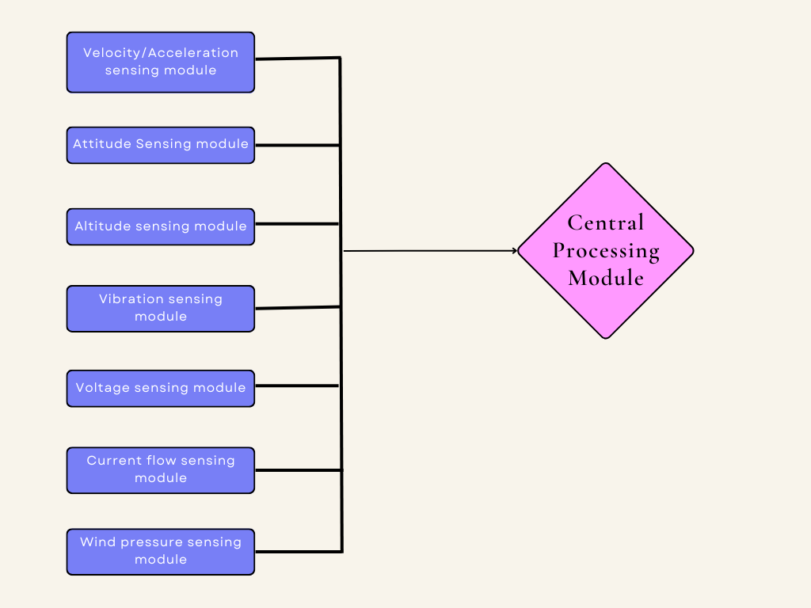

*Image credits: Geethika*